Ideation Phase
Empathize & Discover

Date | 31 January 2025
Team ID | Not specified in project brief
Project Name | Auto Ticket Classification using Flow Designer
Maximum Marks | 4 Marks

Empathy Map Canvas: School IT Helpdesk User
This empathy map captures the needs, behaviours, and frustrations of a student or teacher submitting a school IT support ticket.

The map connects the user experience to the project requirements: simple submission, automatic classification, correct routing, and an email acknowledgement.
The solution must reduce uncertainty for the caller while reducing manual interpretation and rework for the IT helpdesk.
Project user perspective:
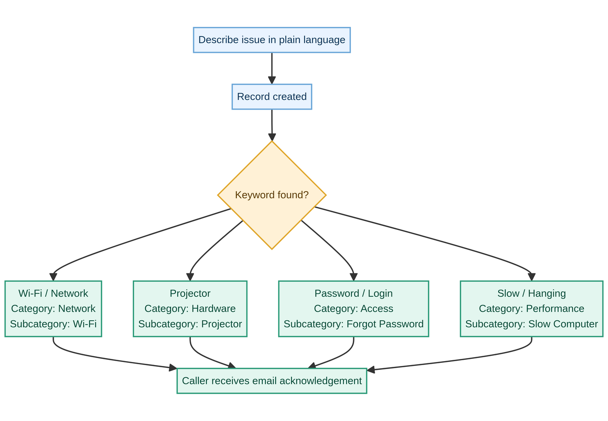

Source: Auto Ticket Classification using Flow Designer project brief

Project journey: from issue description to classified ticket and caller acknowledgement
